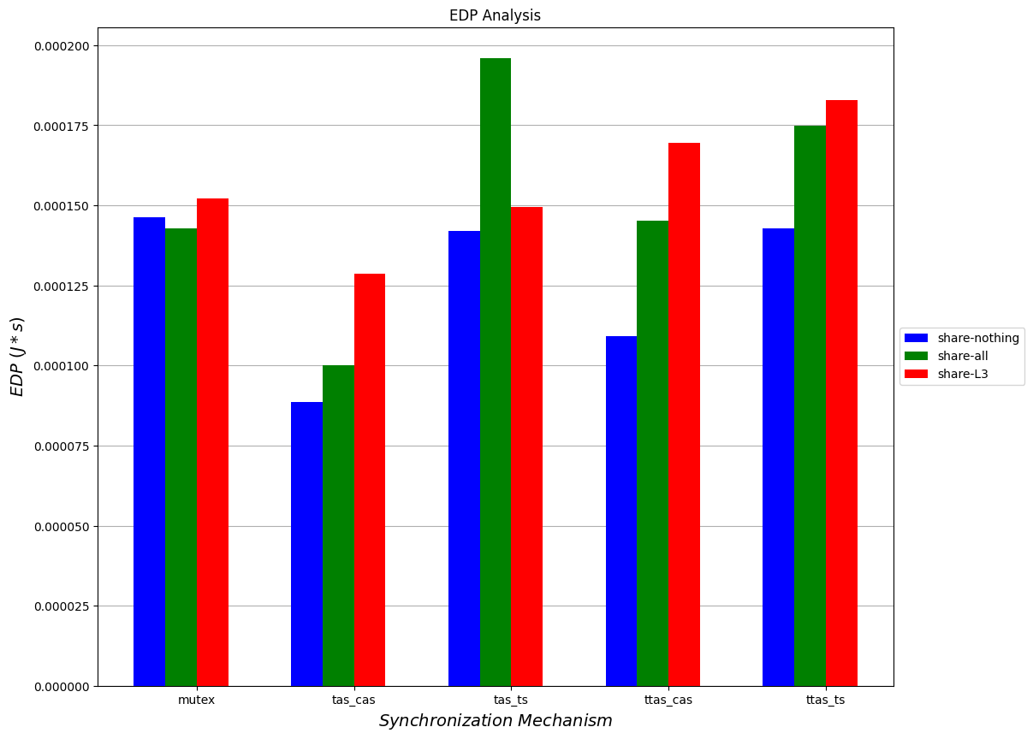

EDP Analysis

0.000200

0.000175

0.000150

0.000125

*EDP ()*5)*

share-nothing share-all share-L3

0.000100

0.000075

0.000050

0.000025

0.000000

mutex

**mutex**

tas cas cunchronization the chanjem

tas cas

**ttas_cas**

**tas_cas**

*tas_ts Synchronization Mechanism*

**ttas_ts**

as tos